EXPERIMENT-12 DHILIPAN M
22/07/2026 192411038

TIC-TAC-TOE GAME
AIM:
To write a Python program to implement the Tic-Tac-Toe game.
ALGORITHM:
Step 1: Create a 3×3 game board initialized with empty spaces.
Step 2: Allow two players to enter their moves alternately (X and O).
Step 3: Validate each move to ensure the selected position is empty.
Step 4: Update the board after every valid move and display the current board.
Step 5: Check for a winning condition after each move by verifying rows, columns, and diagonals.
Step 6: Display the winner if a player wins; otherwise, declare the game as a draw when all cells are filled.
PROGRAM:
board = [' '] * 9
def display():
print()
print(board[0], "|", board[1], "|", board[2])
print("--+---+--")
print(board[3], "|", board[4], "|", board[5])
print("--+---+--")
print(board[6], "|", board[7], "|", board[8])
print()
def check_win(player):
wins = [
(0,1,2), (3,4,5), (6,7,8),
(0,3,6), (1,4,7), (2,5,8),
(0,4,8), (2,4,6)
]
for a, b, c in wins:
if board[a] == board[b] == board[c] == player:
return True
return False
player = "X"
for _ in range(9):
display()
pos = int(input(f"Player {player}, Enter position (1-9): ")) - 1
if board[pos] != ' ':
print("Invalid Move")
continue
board[pos] = player
if check_win(player):
display()
print("Player", player, "Wins!")
break
player = "O" if player == "X" else "X"
else:
display()
print("Game Draw")

OUTPUT:
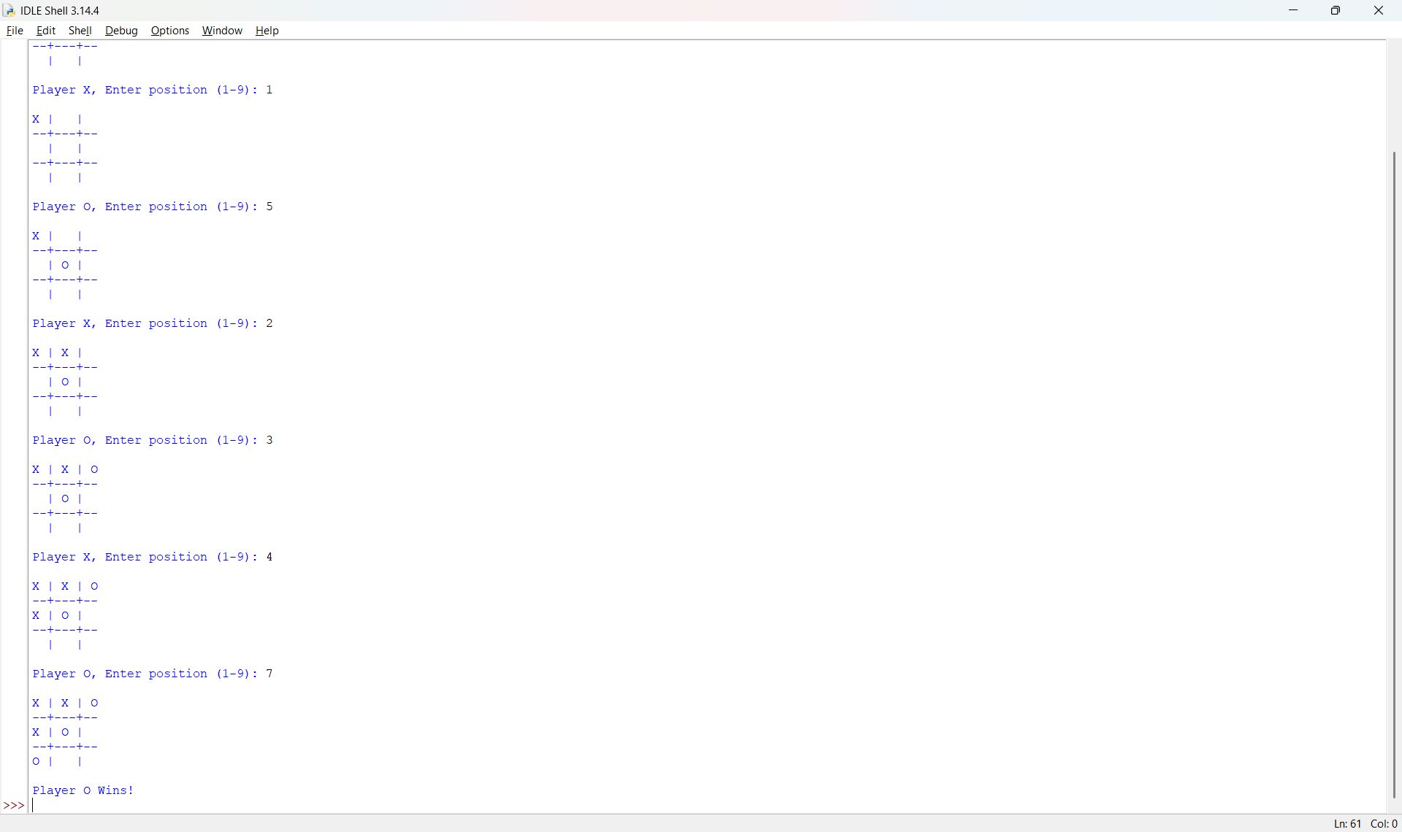

RESULT:
Thus, the Python program to implement the Tic-Tac-Toe game was implemented successfully and the required output was obtained.

